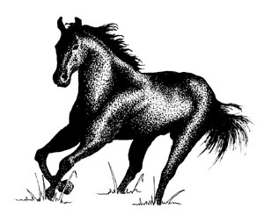
This certifies that
____________________________
has shown outstanding service and dedication to the
Blue Shadows Mounted Drill Team,
has proven excellence in troop involvement,
leadership, enthusiasm and horsemanship
and is a true asset to our organization.

Post __________ Troop Commander___________________
Troop ________ Post Commander ____________________
Date _________ Regimental Commander_______________

